IOS SWIFT GUI PROJECT REPORT

(Project Semester August-December 2023)

# (THE FOOD DELIVERY APPLICATION)

Submitted by

Shalu Kumari

Registration No 12019153

Section K20SK

Course Code INT-234

Under the Guidance of

(Dr. Max Bhatia)

Discipline of CSE/IT



School of Computer Science and Engineering

Lovely Professional University, Phagwara

**Table of content**

|  |  |
| --- | --- |
| Introduction | 1 |
| Overview | 2-3 |
| Features | 4 |
| Screenshots of App | 5-10 |
| Project Features | 11 |
| Learning Outcomes | 11 |
| Conclusion | 12 |

**Introduction**

The Food Delivery Application was designed to be user-friendly and easy to navigate. It has a simple and clean interface, and it is easy to find the desired food item with a genuine price and quality as well as quantity. The app has numerous features that make it reliable and compatible for users to order their food and enjoy it.

**Overview**

Let’s take an overview of the application:

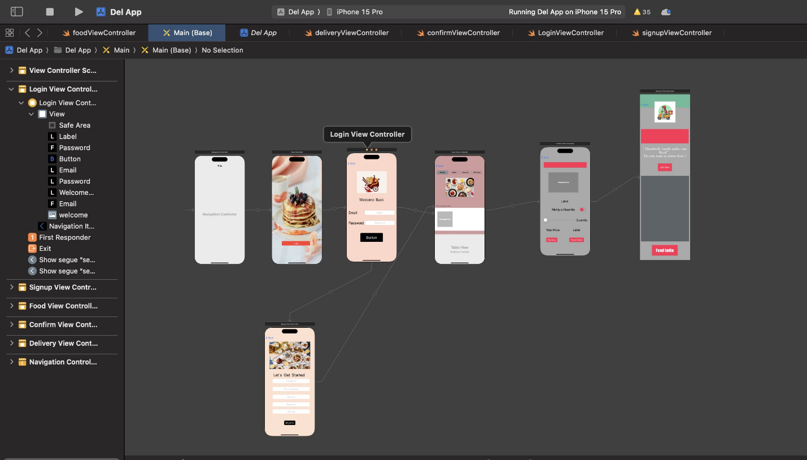

At the very first page you will find login button. When you click on that login button you will land at login page where you have to give email id and password. If you are an existing user then it will validate weather the email and password user had entered is correct or not. If user entered the correct email or password then it will take to content page where they can order their food. Else an alert is pop up with a tone. And it will ask whether the user want to create there account or not. If user click ok then it will take them to the signup page. At this page is user miss any detail then the background color will change to red color. And if user entered there detail then it will take them to main page from where they can order there food. At Main content page there are four categories i.e, “Indian”, ”Italian”, ”Mexican” ,”Chinese”. from there user can select their desired food item. After clicking each segment image animation of that specific category will play. And the food item will display in the table view. The table view contain there name with image. When the user click on the specific row then a pop show the item with their price and ask for the consent of user whether they want to continue the process or not. If user select no then it will do nothing but if user select yes then it will take user to the page where order detail is present, there is an option from where user can select the quantity of food and according to that their price is shown. After that there is an review option where user can see the review of customer and after that they can place the order.

After clicking on place order button. it will take you to the confirmation page where user get confirmation message of delivery. In this page there is an special option called Feed India. In this option people who are interested in donating food to the underprivileged people they can take part and contribute. And also there is an option to see the video clips how we bring the change in our society with these small efforts.

**Features Covered In App**

These are all the features that I have used to make this project

1. Lable
2. Button
3. Text Field
4. Text View
5. Login Signup validation
6. Image View
7. Animated Image view
8. Segue
9. Music
10. Video controller
11. Data transfer
12. Alert
13. Table View
14. Segment
15. Switch
16. Slider
17. Keyboard handling
18. Scroll View
19. Navigation controller
20. Segmented control table view
21. Web view kit

**New features ---**

1. Text View – used text view to show multiline sentence in this app
2. Scroll View – used to scroll down the content which is not visible on the screen the view controller . Using this user can are able to scroll up and down according to there use .
3. Segmented control table view – used to select the specific category at one time and item related to that category.

**Screenshots of the Food Delivery Application**

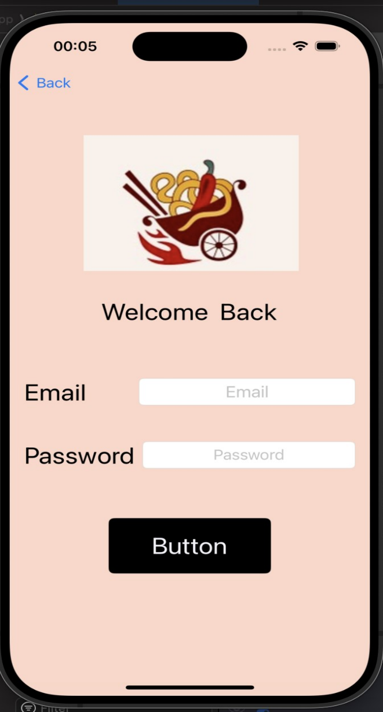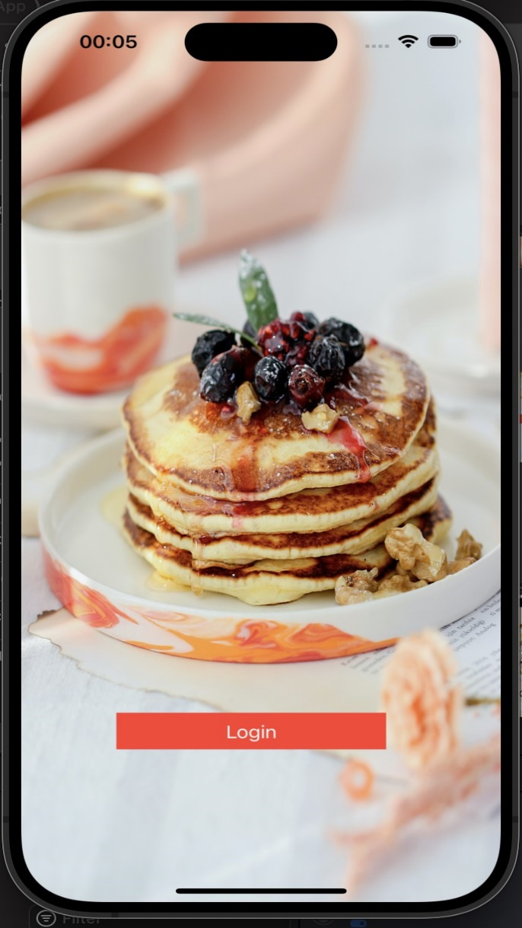

If email and password correct If user not give the correct password or mail

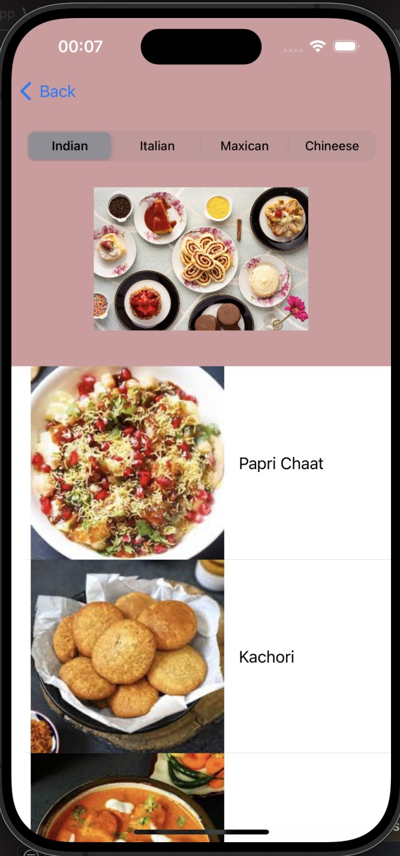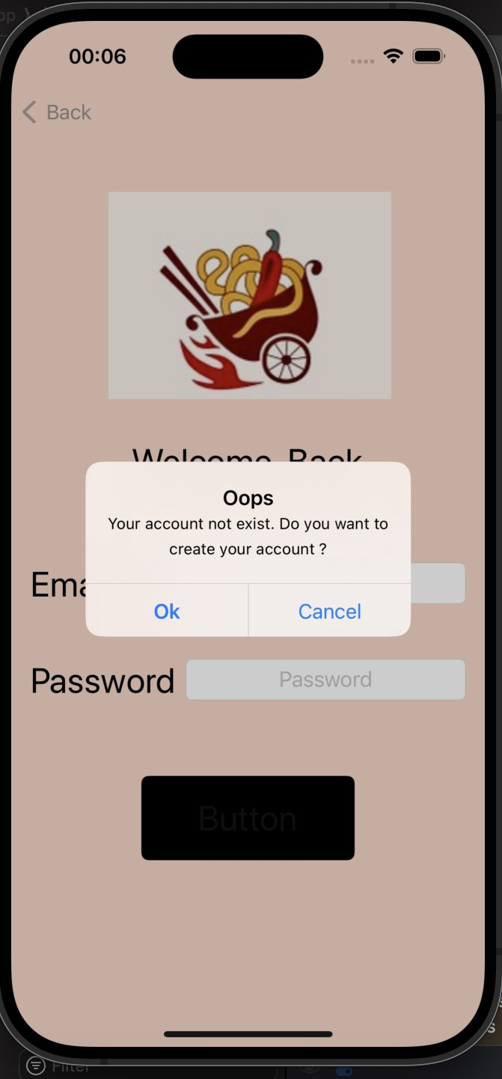

These are about login page after clicking ok in second picture this will take you to the signup page

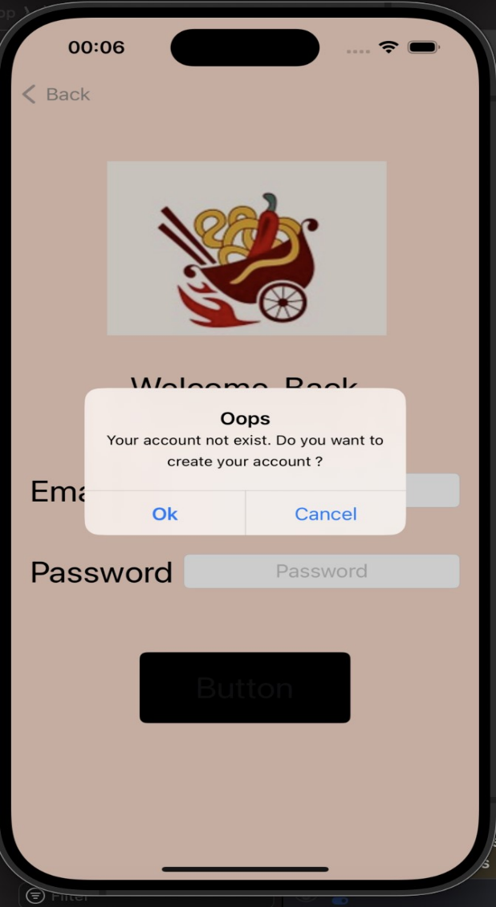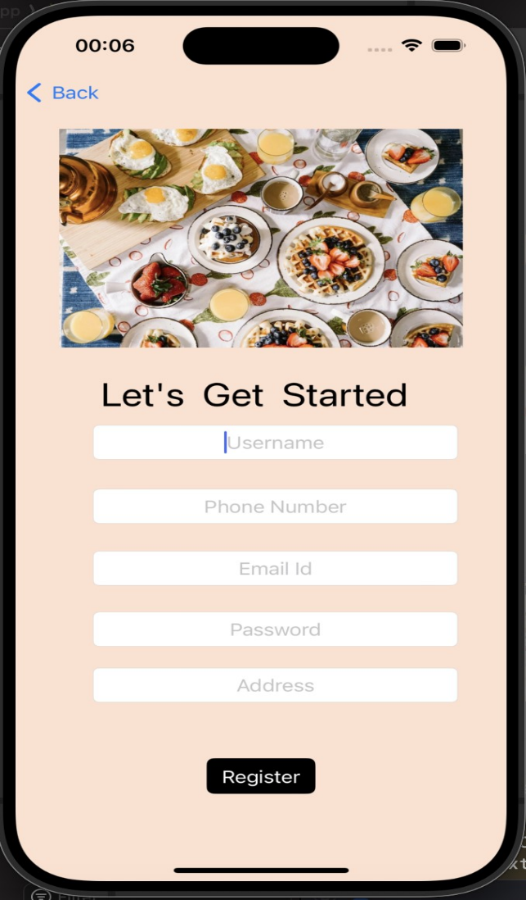

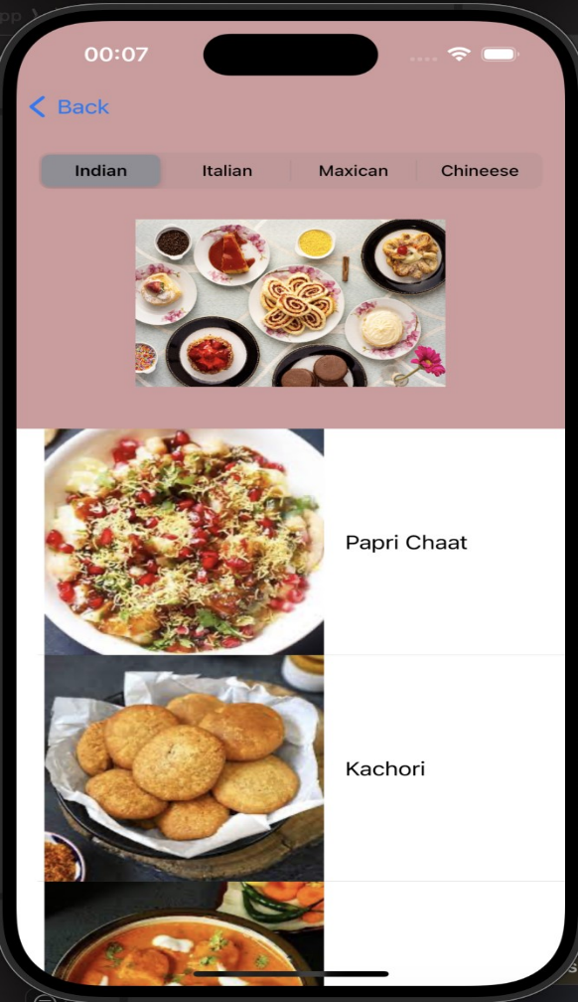 If user doesn’t fill all details

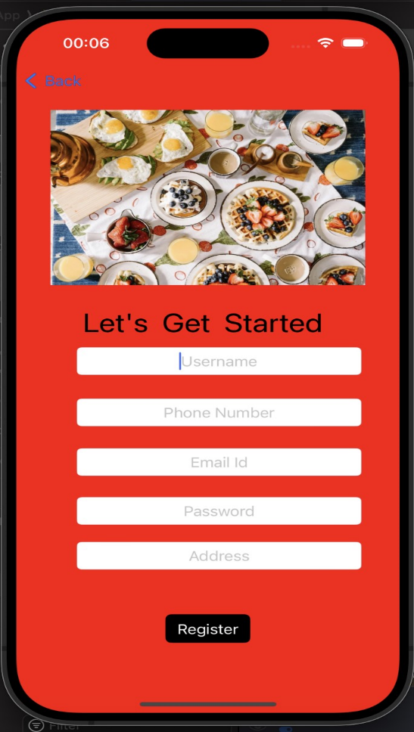

After filling all details

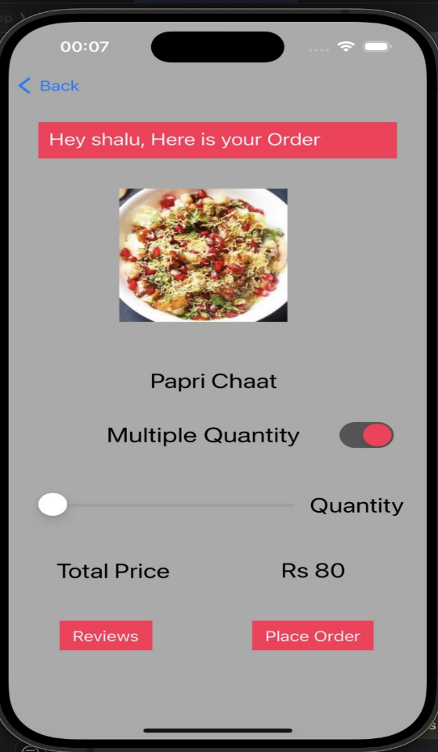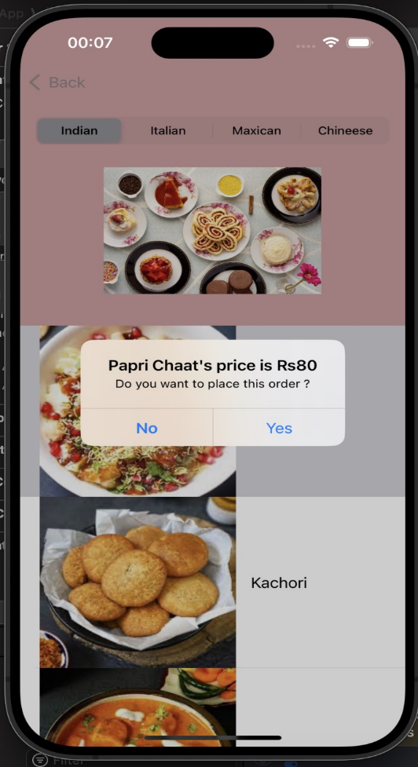

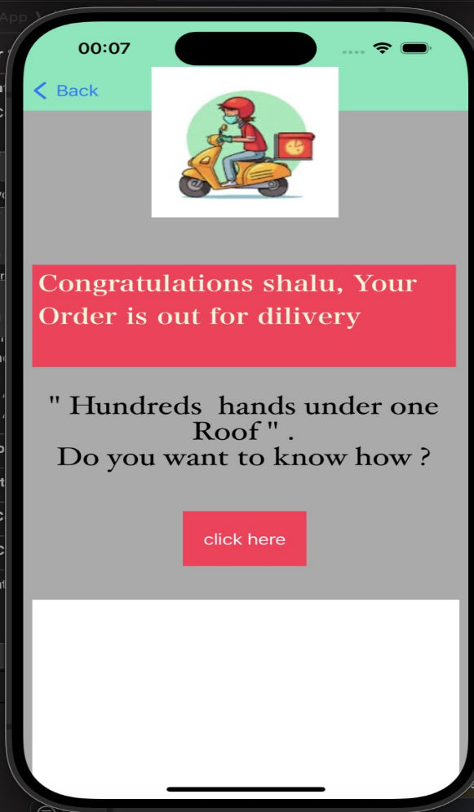

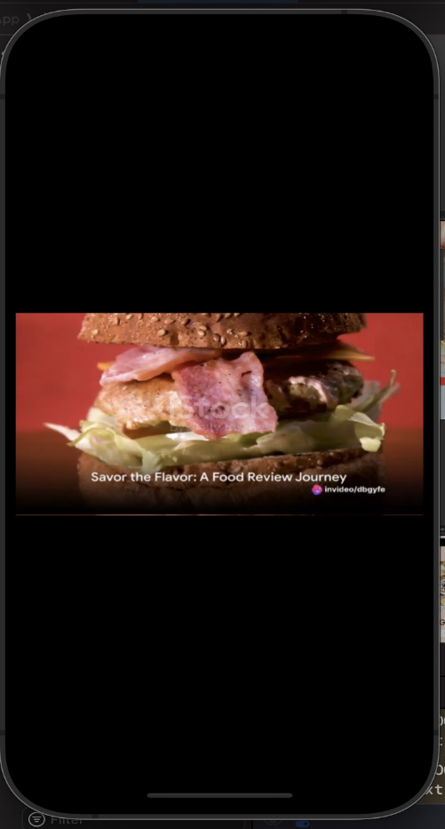

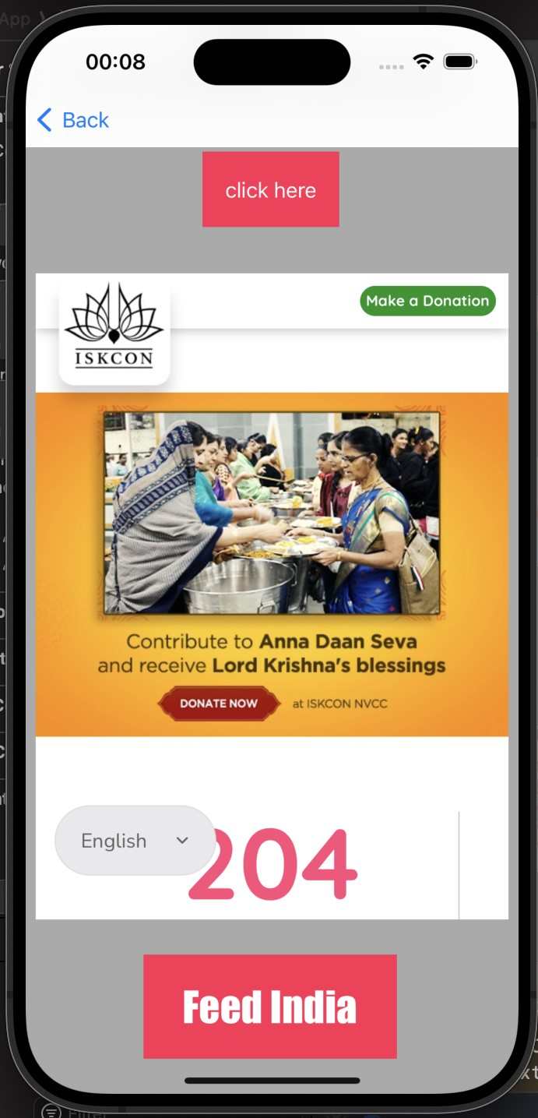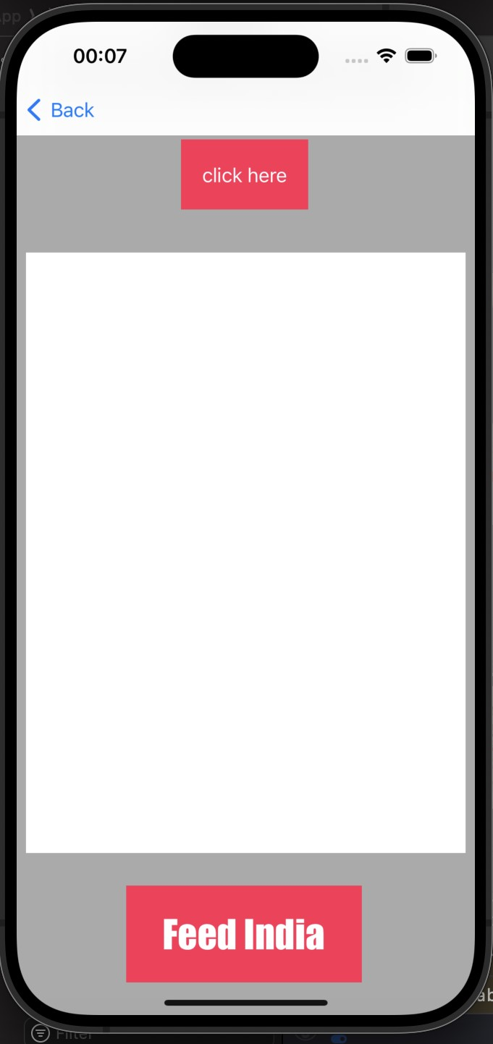

These are the screen shots of application

**Project Features**

* Segmented table view for filtering category of food by the type like Indian, Italian , Mexican, Chineese.
* Animated image view to display animated images related to each category
* Data transfer to transfer username , price , item name and images
* Scroll functionality for viewing more content in same same page
* Web view kit functionality to donate money for food donation
* Video controller for displaying video related to revies and effect of food donation campaign
* Music functionality for giving tone to alert and button click
* Keyboard handling for virtual keyboard in text field

**Learning Outcomes**

* Learned how to use Segment to create a segmented table view, which allow to filter by category.
* Learned how to use animated image view to display animated images in your app
* Learned how to use transfer data to multiple segue
* Learned how to use alert for different purpose
* Implement user registration and validation.

**Conclusion**

In conclusion, the advent of food delivery apps has revolutionized the way we dine. These platforms offer convenience, a wide array of culinary choices, and contactless transactions. Their popularity continues to grow, as they bridge the gap between busy lifestyles and culinary delights. With the integration of cutting-edge technology and evolving customer preferences, food delivery apps are set to remain a vital part of our modern dining experience, shaping the future of the food industry. As we move forward, the key will be to ensure a seamless user experience, maintain high food quality standards, and address environmental concerns, making food delivery apps a sustainable and indispensable part of our lives.